How to Create a Workflow within the BioExtract Server at bioextract.org

Carol Lushbough

University of South Dakota

Carol.Lushbough@usd.edu

This tutorial will demonstrate how to perform a phylogenetic analysis on a set of proteins where the starting point is a query for specific nucleotide gene sequences. The necessary steps for creating this BioExtract Server workflow example involve first querying the NCBI Nucleotide Core data source (http://www.ncbi.nlm.nih.gov) for the liliopsida chloroplast gene petB. Next, the data extract resulting from this query is used as input into Vmatch (see http://www.vmatch.de/) to remove duplicate sequences. The resulting unique records are converted into GenBank format and the fetchTranslation tool is invoked. The execution of the fetch translation tool returns the protein translations from the GenBank-annotated coding sequence (CDS) regions (in FASTA format). Finally, the ClustalW (http://www.clustal.org/) tool is executed to create the multiple sequence alignment with the input specified as coming from the previously executed tool (i.e., the extracted protein sequences) and to define and draw a dendrogram that represents how the sequences are related.

- Signing in as a Registered User
In order to save the workflow, sign in as a registered user before continuing with the tutorial.
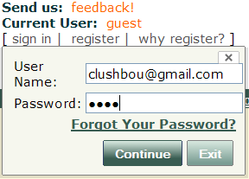
- Prepare for Recording
BioExtract Server workflows are created by “recording” in the background steps executed by users as they work with the system. When first signing into the BioExtract Server, the recording area is empty. But, if there have been previously executed steps that are not meant to be part of the workflow being created, click on the Create and Import Workflows node on the Workflow tab. Then click the button.
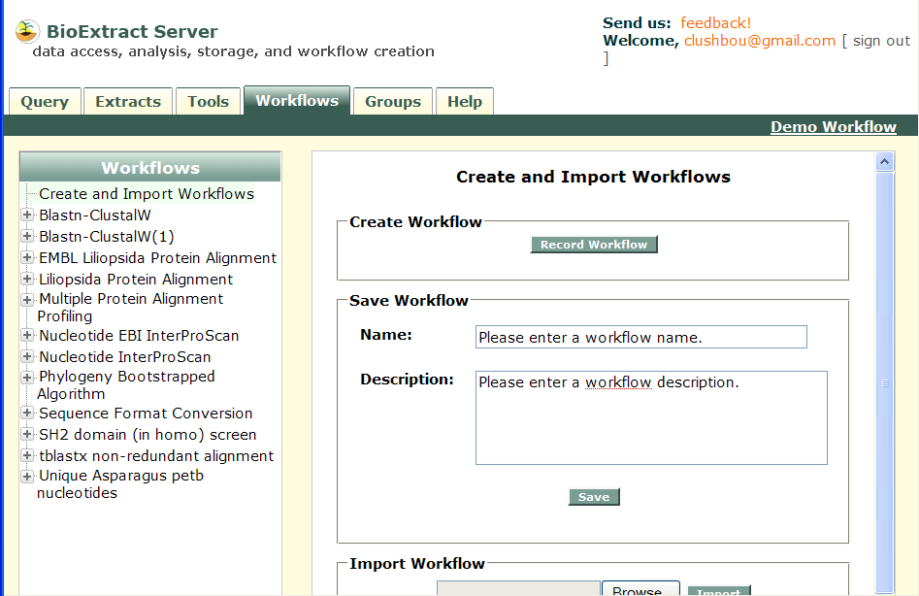
Clear workflow recording area
- Executing the Query
- Click the “Query” tab
- Select the NCBI Core Nucleotide data source from the list of available data sources.
- Select the Organism search filed and enter liliopsida
- Click the three times
- Select the Definition search field and enter the term chloroplast
- Select the Definition search field and enter the term petB
- Select the Definition search field and enter the term gene
- Click the button
- Click the “Extracts” tab to view the results. 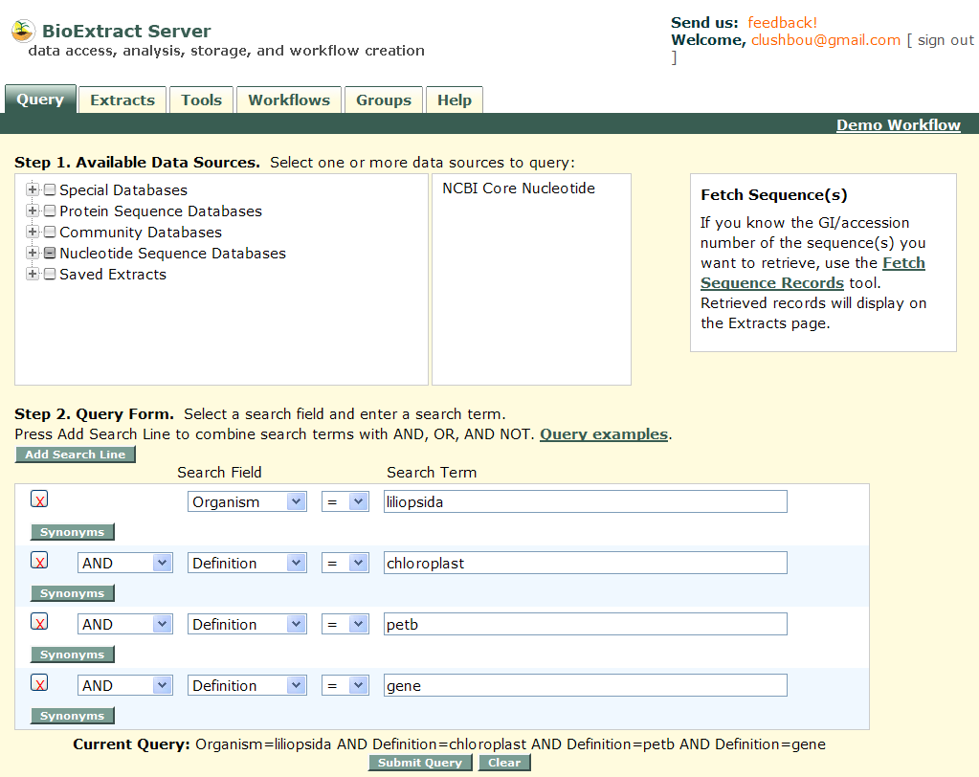
- Remove the Duplicate Records

- Click the “Tools” tab
- Select the xmknr tool under the Edit Tools node in the Available tools tree
- Select the Use records on Extracts page formatted as FASTA as the Input Data (Note: the input into the xmknr tool will be the records listed on the Extracts tab.)
- Select dna for the Sequence Type parameter.
- Click the button at the bottom of the screen. (Note: this tool will modify the list of records listed on the “Extract” tab.)
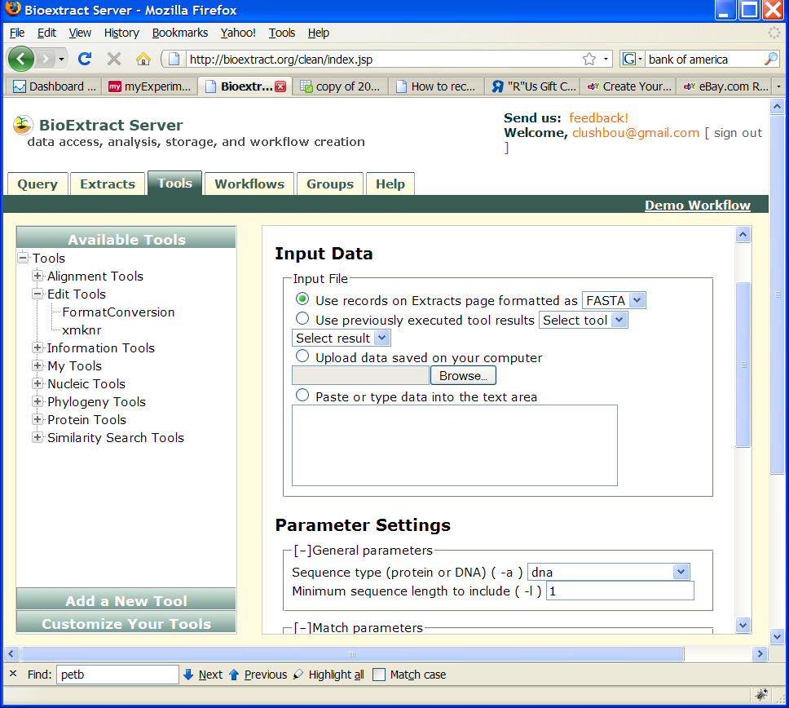
- Retrieve Records in GenBank format

- Select the Format Conversion tool under the Edit Tools node in the Available Tools tree
- Select the Use records on Extracts page formatted as FASTA as the Input Data (Note: the input into the format conversion tool will be the records listed on the Extracts tab.)
- Set the To Format parameter to genbank
- Set the From Format parameter to fasta
- Click the button.

- Retrieve Protein Translations from the CDS regions

- Select the Fetch Translations tool under the Information tools node in the Available Tools tree.
- Select the Use previously executed tool results as the Input Data and select FormatConversion and result.txt.
- Click the button.
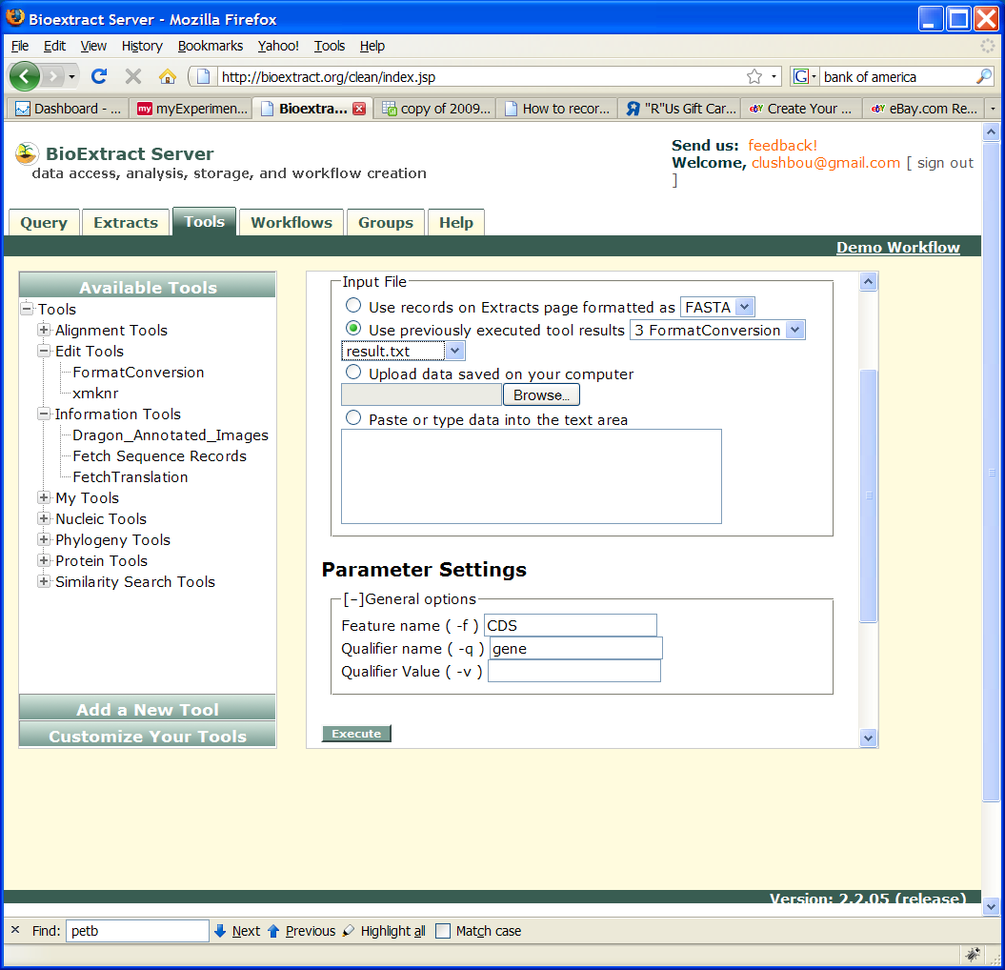
- Create a Multiple Sequence Alignment and Dendrogram

- Select ClustalW under the Alignment Tools node in the Available Tools tree
- Select the Use previously executed tool results as the Input Data and select Fetch Translations and fetchTranslations_results.txt.
- Click the button.

- Saving the Workflow

- Select the “Workflow” tab
- Enter Liliopsida petb protein alignment in the Name field.
- Enter Liliopsida petb protein alignment in the Description field.
- Click the button.
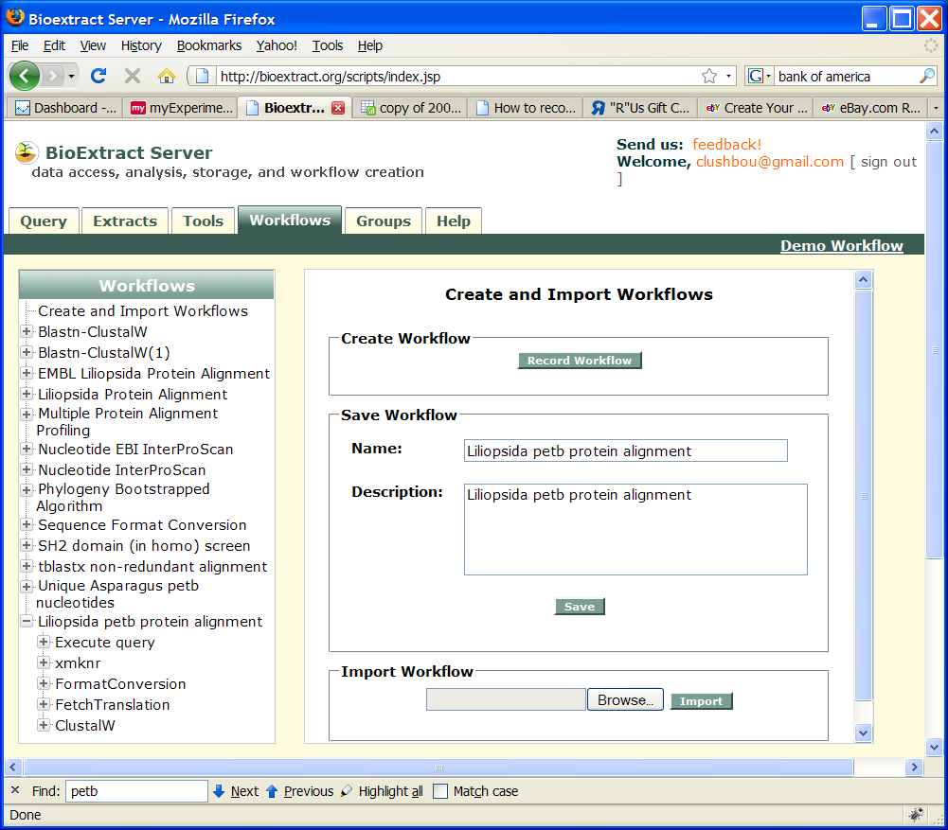
- Testing the Workflow
- On the “Workflows” tab, click the new workflow's name. The workflow opens in the right panel.
- Click on the button. The workflow begins to run.
- After a step has completed execution, it will turn blue. At that point the output can be viewed.
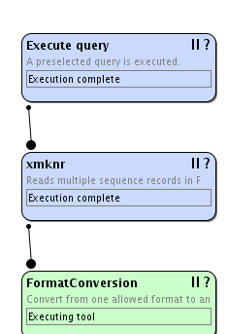
Click to view output
