Supporting data for Antarctic Science paper, Soils of western Wright Valley, Antarctica.
McLeod et al. (2009). Doi:10.1017/S0954 10200900 1965

Description: WV07-22
Location: Labyrinth
Grid reference: S77.52193 E161.8235
Landform: Ground moraine
Patterned ground: Fossil sandwedges in profile
Weathering stage: 5
Salt stage: 2
Rock ghosts: 8 cm
Depth of coherence: > 80 cm
Depth of visible salts: 24 cm
Depth of staining: > 80 cm
Classification: Typic Anhyturbel
Notes: Extremely well-developed doleritic desert pavement with low surface boulder frequency, dolerite pitted ventifacted and varnished, some ventifacted sandstone

Horizon  designation | Depth  (cm) | Description WV07-22
D  Bwjj1  Bwz  Bwjj2  Bwjj3  Bw | 0–1  1–7  7–17  17–30  30–53  53–80+ | Dry; light pale brown (10YR 6/3) very gravelly sand; 2% stones; 5% cobbles; 40% subangular gravel; doleritic stained ventifacts, single grain; loose; salts under stones; abrupt smooth boundary.  Dry; yellowish red (5YR 5/6) gravelly sand; 4% subangular doleritic gravel; massive breaking to single grain; slightly hard; weakly cemented; salts under stones, abrupt irregular boundary.  Dry; light yellowish brown (10YR 6/4) gravelly sand; 8% subangular doleritic gravel; single grain; soft; few salt flecks (<20%); abrupt smooth boundary.  Dry; light yellowish brown (10YR 6/4) gravelly sand; 20% subangular doleritic gravel; single grain; soft; salts under stones; abrupt wavy boundary.  Dry; yellowish brown (10YR 5/6) gravelly sand; 27% subangular doleritic gravel; single grain; soft; salts under stones; clear wavy boundary.  Dry; yellowish brown (10YR 5/6) gravelly sand; 32% subangular doleritic gravel; single grain; soft; salts under stones; clear wavy boundary.

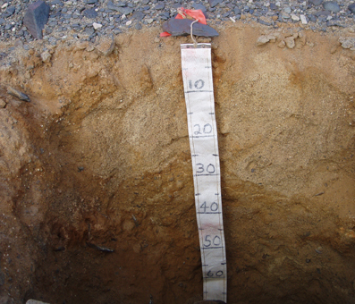  Fig. 3. ProfileWV07-22 at S77.52193 E160.8235 | 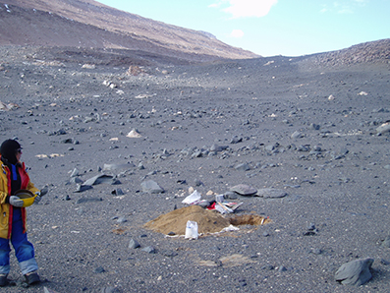  Fig. 4. Profile WV07-22 landscape.

Description: WV07-46
Location: Dais
Grid reference: S77.54969 E161.24763
Landform: Nearly flat surface on Dais sloping 5° facing south
Patterned ground: None
Weathering stage: 6
Salt stage: 3
Rock ghosts: 22 cm
Depth of coherence: > 60 cm
Depth of staining: > 60 cm
Depth of visible salts: 45 cm
Classification: Salic Anhyorthel
Notes: No sand wedge casts

Horizon  designation | Depth  (cm) | Description WV07-46
D  Bw  Bwz  Bw | 0–1  1–9  9–28  28-56+ | Dry; light brownish grey (2.5Y 6/2) extremely gravelly sand; 78% ventifacted diabase and subangular gneiss gravel; single grain; loose; salts under stones; abrupt smooth boundary.  Dry; strong brown (7.5YR 5/6) very gravelly sand; 10% cobbles; 68% gravel of subangular dolerite and gneiss; single grain; loose to soft; salts under stones, abrupt wavy boundary.  Dry; strong brown (7.5YR 4/6) very gravelly loamy sand; 10% cobbles; 45% gravel of subangular dolerite and gneiss with mineral coatings; single grain; soft; many (>20%) salt flecks, abrupt wavy boundary.  Dry; brownish yellow (10YR 6/6) very gravelly sand; 10% cobbles; 45% gravel of subangular dolerite and gneiss with mineral coatings; single grain; soft; few (<20%) salt flecks, abrupt wavy boundary.

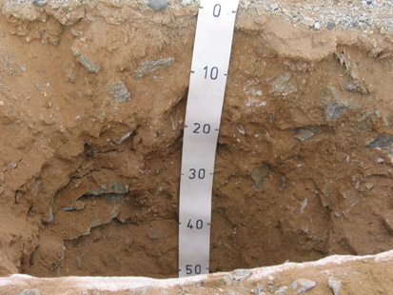  Fig. 5. ProfileWV07-46. | 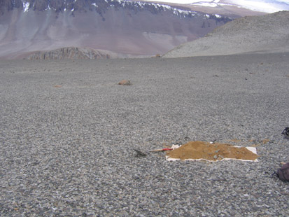  Fig. 6. Profile WV07-46 landscape.

Description: WV07-04
Location: Don Juan pond, South Fork
Grid reference: S77.56409 E161.20024
Landform: Pond margin
Patterned ground: None
Weathering stage: 3.5
Salt stage: 4
Rock ghosts: 0 cm
Depth of coherence: 0 cm
Depth of visible salts: 2 cm
Depth of staining: 0 cm
Classification: Salic Aquorthel
Notes: Water table at 32 cm

Horizon  designation | Depth  (cm) | Description WV07-04
Dz  Cnz1  Cnz2 | 0–2  2–15  15–32 | Dry; brownish yellow (10YR 6/6) gravelly sand; massive; slightly hard; weakly cemented; salt stage IV; abrupt smooth boundary.  Moist; very dark greyish brown (2.5Y 3/2) sand with 1–3 cm thick black (10YR 2/1) layers; single grain; loose; salt stage III; abrupt smooth boundary.  Moist; dark yellowish brown (10YR 3/6) sand; single grain; loose; salt stage II–III; abrupt smooth boundary.  Notes: Water table 32 cm. Weathering stage 3 to 4.Salt stage 4

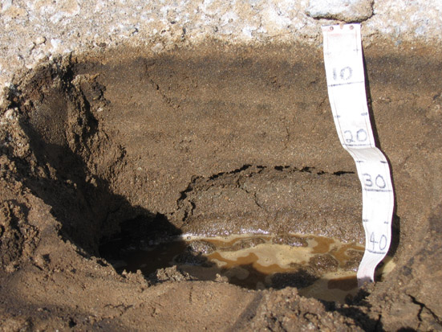  Fig. 7. ProfileWV07-04 at S77.56409 E161.20024 | 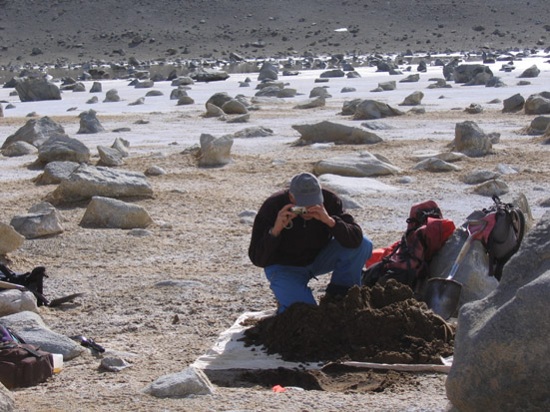  Fig. 8. Profile WV07-04 landscape.

Description: WV07-11
Location: South Fork
Grid reference: S77.56385 E161.32204
Landform: Wright Upper III lateral moraine
Patterned ground: None
Weathering stage: 4
Salt stage: 1
Rock ghosts: 16 cm
Depth of coherence: 20 cm
Depth of visible salts: 47 cm
Depth of staining: 0 cm
Classification: Typic Anhyorthel
Notes: Some weak stratification in upper profile

Horizon  designation | Depth  (cm) | Description WV07-11
D  Bw  Cn1  Cn2  Cnfm | 0–1  1–20  20–47  47–81  81+ | Dry; light brownish grey (2.5Y 6/2) very gravelly sand; 5% stones; 15% cobbles; 50% fresh angular gravel; single grain; loose; salt stage I; abrupt smooth boundary.  Dry; brown (10YR 5/3) very gravelly sand; 10% stones; 10% cobbles; 30% angular and stained gravel; single grain; slightly hard; weakly cemented; salt stage II; clear wavy boundary.  Dry; greyish brown grey (2.5Y 5/2) very gravelly sand; 25% stones; 25% cobbles; 22% sub-rounded and stained gravel; single grain; loose; salt stage II; clear wavy boundary.  Dry; light yellowish brown (2.5Y 6/4) gravelly sand; 5% stones; 10% cobbles; 20% sub-rounded and stained gravel; single grain; loose; salt stage 0; sharp wavy boundary.  Ice-cemented permafrost.

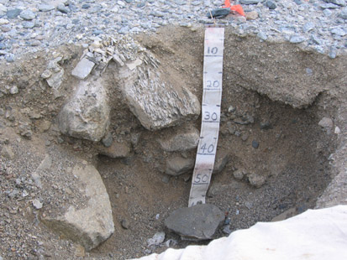  Fig. 9. ProfileWV07-11 at S77.56385 E161.32204 | 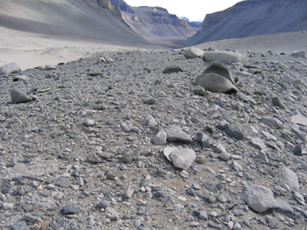  Fig. 10. Profile WV07-11 landscape.

Description: WP321
Location: South Fork
Grid reference: S77. 77.56496 E161.34895
Landform: Small lake? basin
Patterned ground: None
Weathering stage: 3
Salt stage: 3
Rock ghosts: 0 cm
Depth of coherence: > 71 cm
Depth of visible salts: 20 cm
Depth of staining: 34 cm
Classification: Salic Anhyorthel
Notes: 34 cm reworked Peleus till on sand

Horizon  designation | Depth  (cm) | Description WP321
D  Bw1  Bwz  Bw2  2Cn1  2Cn2  2Cnfm | 0–1  1–8  8–20  20–34  34–44  44–71  71+ | Greyish brown (2.5Y 5/2) sand.  Olive yellow (2.5Y 6/6) silt loam, salt stage II, reworked Peleus till.  Olive yellow (2.5Y 6/6) silt loam, salt stage III, reworked Peleus till.  Olive yellow (2.5Y 6/6) silt loam, salt stage I, reworked Peleus till.  Light yellowish brown (2.5Y 6/4) sand.  Light brownish grey (2.5Y 6/2) sand.  Ice-cemented permafrost.

Description: WV07-12
Location: South Fork
Grid reference: S77.57068 E161.30293
Landform: Colluvial fan
Patterned ground: Strongly developed flat centered polygons 20 × 20 m. Troughs 20 cm deep, recently reamed by water, stones in trough
Weathering stage: 2
Salt stage: 1
Rock ghosts: 0 cm
Depth of coherence: 22 cm
Depth of visible salts: 1 cm
Depth of staining: 22 cm
Classification: Typic Haploturbel

Horizon  designation | Depth  (cm) | Description WV07-12
D  Bwjj  Cox  Coxfm | 0–1  1–15  15–22  22–30+ | Dry; greyish brown grey (2.5Y 5/2) very gravelly sand; 3% stones; 10% cobbles; 63% angular and fresh gravel; single grain; loose; carbonates at salt stage I; abrupt smooth boundary.  Dry; yellowish brown (10YR 5/4) sand; 1% sub-rounded and stained gravel; massive breaking to single grain; slightly hard; weakly cemented; salt stage 0; clear wavy boundary.  Moist; yellowish brown (10YR 5/6) gravelly sand; 22% angular and stained gravel; single grain; loose; salt stage 0; abrupt wavy boundary.  Moist; yellowish brown (10YR 5/4) sand; ice-cemented permafrost.

Description: WP203
Location: North Fork
Grid reference: S77. 52986 E161. 23943
Landform: Transverse ridge of bedrock dykes in valley
Patterned ground: None
Weathering stage: 5
Salt stage: 1
Rock ghosts: 0 cm
Depth of coherence: > 70 cm
Depth of visible salts: 26 cm
Depth of staining: 37 cm
Classification: Typic Anhyorthel

Horizon  designation | Depth  (cm) | Description WP203
D  Bw  Cn | 0–1  1–37  37–70+ | Dry; greyish brown grey (2.5Y 5/2) very gravelly sand; loose; abrupt smooth boundary.  Dry; pale yellow (5Y 7/3) sandy loam; massive breaking to single grain; very friable.  Dry; light grey (5Y 7/2) sandy loam slightly hard; massive breaking to medium angular block.

Description: WV07-33
Location: North Fork
Grid reference: S77.53677 E161.32957
Landform: Valley floor
Patterned ground: None
Weathering stage: 3.8
Salt stage: 2
Rock ghosts: 0 cm
Depth of coherence: > 100 cm
Depth of visible salts: 46 cm
Depth of staining: > 100 cm
Classification: Typic Anhyturbel
Notes: Four fossil sand wedges in profile with average depth is 27 cm, width at top 2 cm and at base 1 cm

Horizon  designation | Depth  (cm) | Description WV07-33
D  Bw  BWz  Cox |  | Dry; light brownish grey (2.5Y 6/2) very gravelly sand; 2% stones; 5% cobbles; 45% gravel; single grain; loose; salts under stones; abrupt smooth boundary.  Dry; strong brown and yellowish brown(7.5YR 4/6 + 10YR 5/6) loamy sand; 10% subangular and stained dolerite and gneiss fine gravel; massive breaking to single grain; soft but slightly hard in places; weakly cemented in places; salts under stones; clear wavy boundary.  Dry; strong brown (7.5YR 4/6) loamy sand; 5% subrounded and stained dolerite gravel; single grain; soft; few (<20%) salt flecks; gradual wavy boundary.  Dry; l yellowish brown (10YR 5/6) loamy sand; 6% subrounded and stained dolerite gravel; single grain; soft; salts under stones.

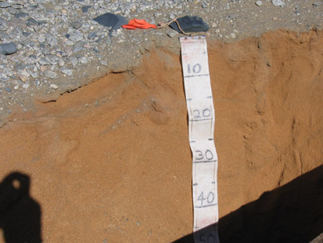  Fig. 11. ProfileWV07-33 at S77.53677 E161.32957 | 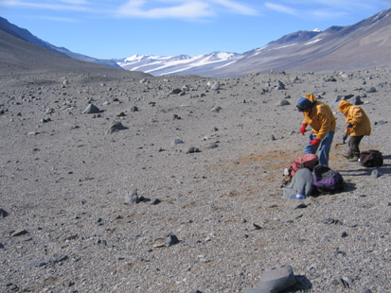  Fig. 12. Profile WV07-33 landscape looking east along the North Fork.

Description: WV07-30
Location: North Fork
Grid reference: S77.53938 E161.38551
Landform: Valley floor
Patterned ground: Moderately developed flat centered 15 × 15 m
Weathering stage: 2
Salt stage: 1
Rock ghosts: 24 cm
Depth of coherence: 37 cm
Depth of visible salts: 1 cm
Depth of staining: 37 cm
Classification: Typic Haploturbel
Notes: Lake sediments are laminated 3–10 mm thick. Fossil sand wedges to 37 cm.

Horizon  designation | Depth  (cm) | Description WV07-30
D  Cn  2Bw  2Cox  Coxfm | 0–1  1–11  11–37  37–48  48+ | Dry; greyish brown grey (2.5Y 5/2) very gravelly sand; 10% stones; 25% cobbles; 42% angular fresh gneiss and ventifacted diabase gravel; single grain; loose; few salt coatings underneath stones, cobbles and gravels; abrupt smooth boundary.  Dry; light brownish grey (2.5Y 6/2) gravelly sand;26% subangular weakly stained gneiss gravel; single grain; loose; no observable salts; clear wavy boundary.  Dry; pale brown (10YR 6/3) gravelly loamy sand; 20% stones; 36% gravel with mineral coatings; massive breaking to moderately developed medium block; slightly hard; weakly cemented; vesicular porosity; inclusions of fine algal matt material; clear wavy boundary.  Dry; pale brown (10YR 6/3) gravelly loamy sand; 30% subangular gravel with mineral coatings; moderately developed medium block; soft; vesicular porosity; inclusions of fine algal matt material; abrupt wavy boundary.  Moist ice-cemented permafrost.  Notes: Sand wedges to 37 cm with top width 3 cm and 1 cm at bottom.

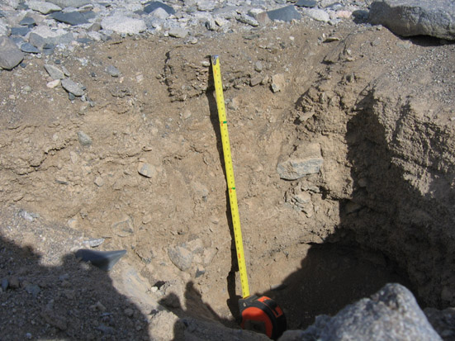  Fig. 13. ProfileWV07-30 at S77.53938 E161.38551. | 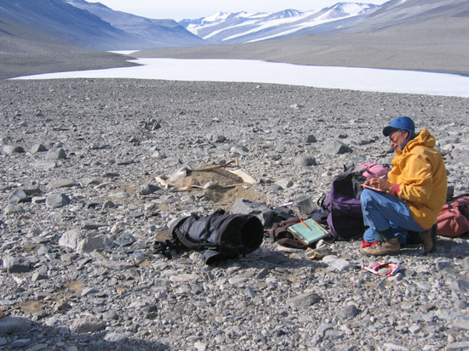  Fig.14. Profile WV07-30 landscape with Lake Vanda in background.

