Choice for promoter region for the chromatin states analysis

The overlap of between gene promoters and genomic regions was set to 100 as that was considered to be a reasonable amount of base pairs that we can define as an overlap. We also run our workflows with the overlap parameter set to 1 , and the promoter region size for 1, 100, 500, 1000 and 2000. The results were similar as the ones we include below, but the ones with an overlap of 100 were slightly better.

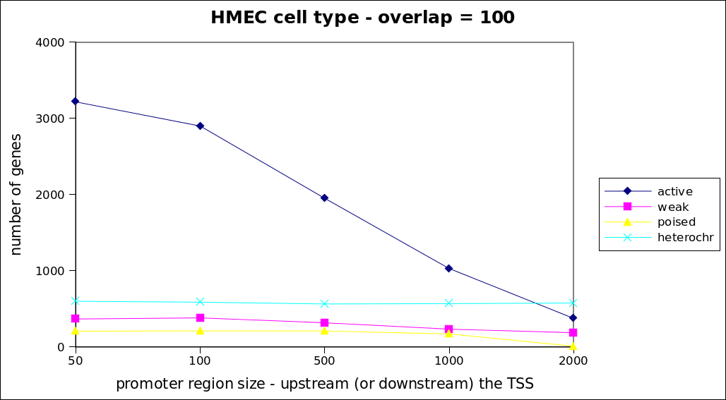Illustration 1 The workflow compute_overlaps was adjusted to include an extra component from the workflow map genes to chr location, to compute a different promoter region at each time. 5 different values were tested that correspond to the side upstream (or downstream) the TSS. The final promoter region was computed as x2 the value in the x-axis. The number of genes corresponds to the genes that overlap with only one chromatin state. The highest separation was achieved for a promoter region of 50 base pairs.

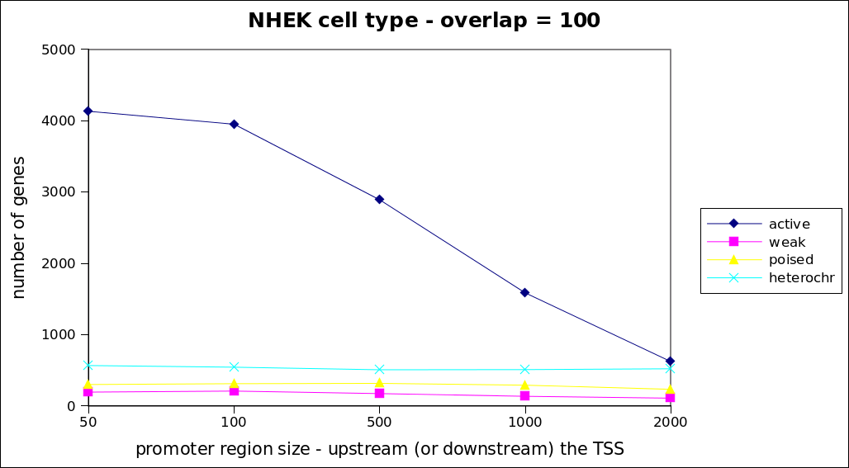Illustration 2 The workflow compute_overlaps was adjusted to include an extra component from the workflow map genes to chr location, to compute a different promoter region at each time. 5 different values were tested that correspond to the side upstream (or downstream) the TSS. The final promoter region was computed as x2 the value in the x-axis. The number of genes corresponds to the genes that overlap with only one chromatin state. The highest separation was achieved for a promoter region of 50 base pairs.

Choice of promoter region for the CpG island analysis
The decision of the promoter region for the CpG island analysis was taken in collaboration with the domain experts discussing an appropriate size for a promoter region in this part of our analysis. CpG islands located within a promoter region can affect gene transcription. This region can vary from tens of base pairs to thousands, and even including thousands that are remote from currently annotated promoters. Previous knowledge and years of related experience by our domain experts resulted into deciding for a promoter region of 5000 bp upstream and 2000 bp downstream.
To validate such an intuition we run our workflows with different settings for the promoter region and overlap variables. We took also into consideration the length of the CpG islands. The minimum length of a CpG island is 201, with a mean of 759.7 and a maximum of 45712. We counted the number of genes overlapping with a CpG island for each of the different promoter and overlap settings. As it becomes obvious from the figure, after the 700 bps there is not such a big difference on the amount of genes that overlap with a CpG island. In addition the overlap size does not affect the amount of genes either. Therefore we decided to follow our initial decision which was taken under the guidance of our domain experts.

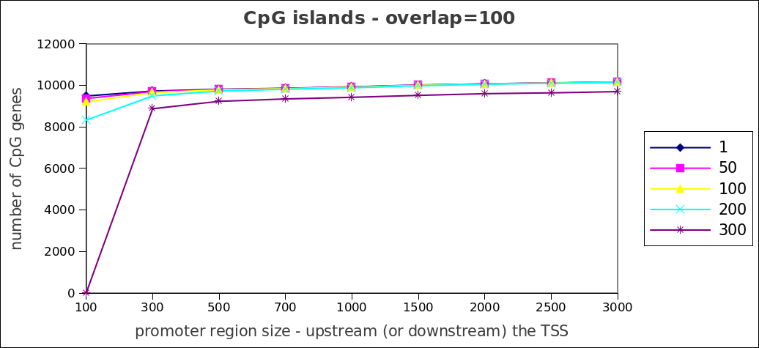Illustration 3 The workflow compute_overlaps was adjusted to include an extra component from the workflow map genes to chr location, to compute a different promoter region at each time. 9 different values were tested that correspond to the side upstream (or downstream) the TSS. The final promoter region was computed as x2 the value in the x-axis. The number of genes corresponds to the genes that overlap with CpG islands. The different plot lines correspond to different overlap sizes.

